ROOM TEMPERATURE MONITORING

SYSTEM

DONE BY:

K.PRIYANKA

T.DHANALAKSHMI

P.V.PADMAVATHI

ABOUT THIS PROJECT:

In this project, we will use the ESP-32 ARDUINO DHT11 temperature/humidity sensor and display it to the arduino IDE serial monitor.This project is really simple and shouldn’t take us very long.

BLOCK DAIGRAM:

AR

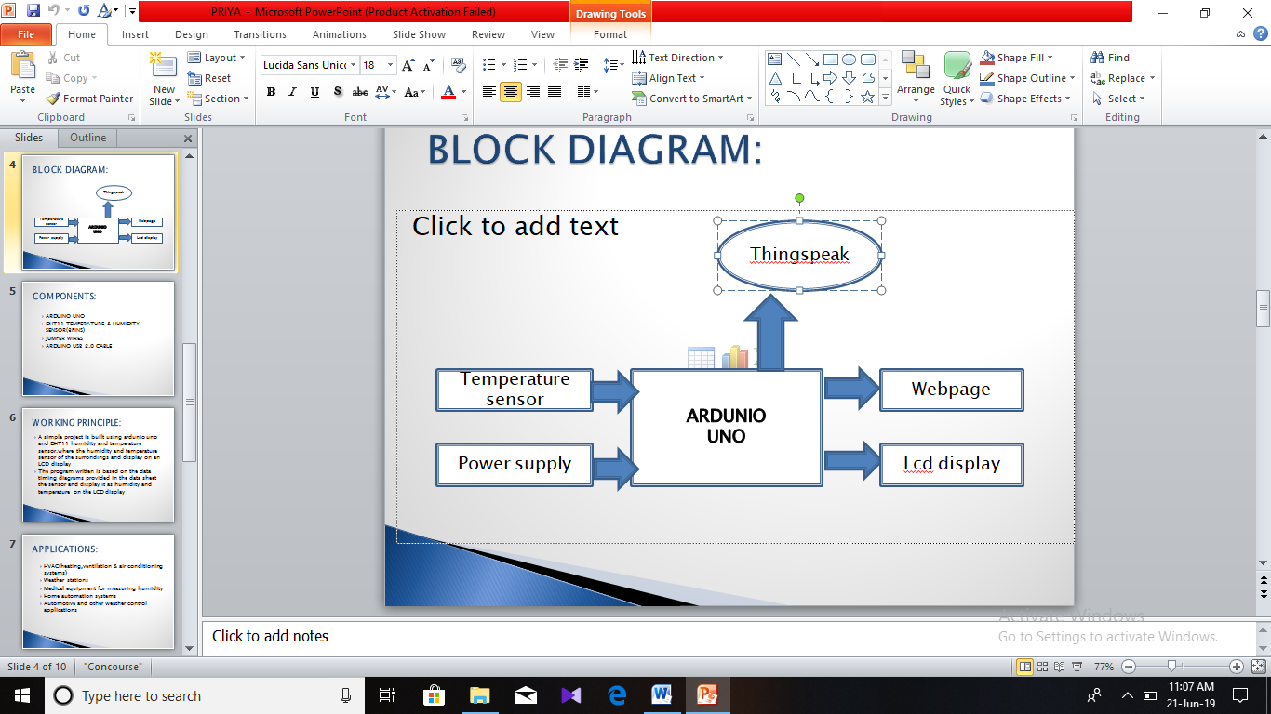

COMPONENTS:

* ARDUINO UNO
* DHT11 TEMPERATURE&HUMIDITY SENSOR
* JUMPER WIRES
* ARDUINO USB 2.0 CABLE

WORKING PRINCIPLE:

* A simple projet is ardunio UNO and DHT11 humidity and temperature sensor
* Where the humidity and temperature sensor are displayed on the lcd display
* After making the connections we need not do anything as the program will take care of everything
* This is based on tne data timing diagram

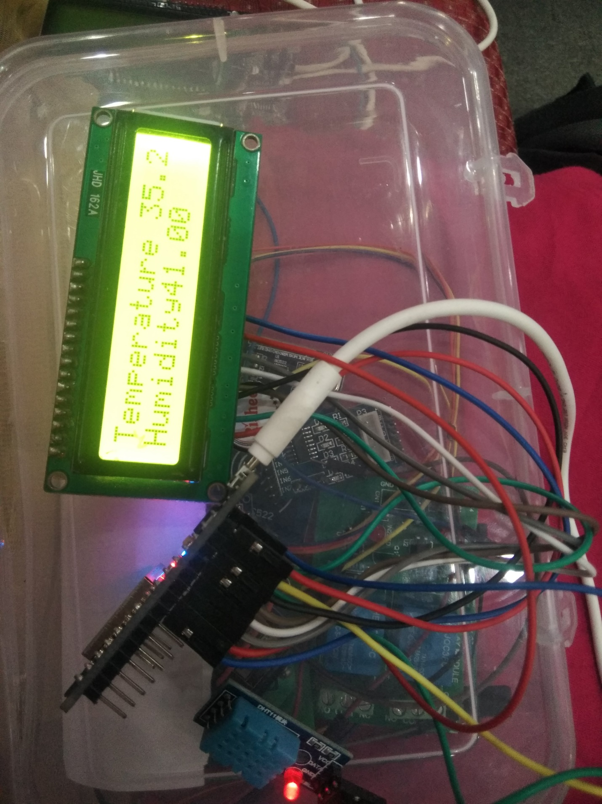

APPLICATIONS:

* HVAC
* WEATHER CONDITIONS
* MEDICAL EQUIPMENT FOR MEASURING HUMIDITY
* HOME AUTOMOTION SYSTEM
* AUTOMOTIVE AND WEATHER CONTROL APPLICATIONS

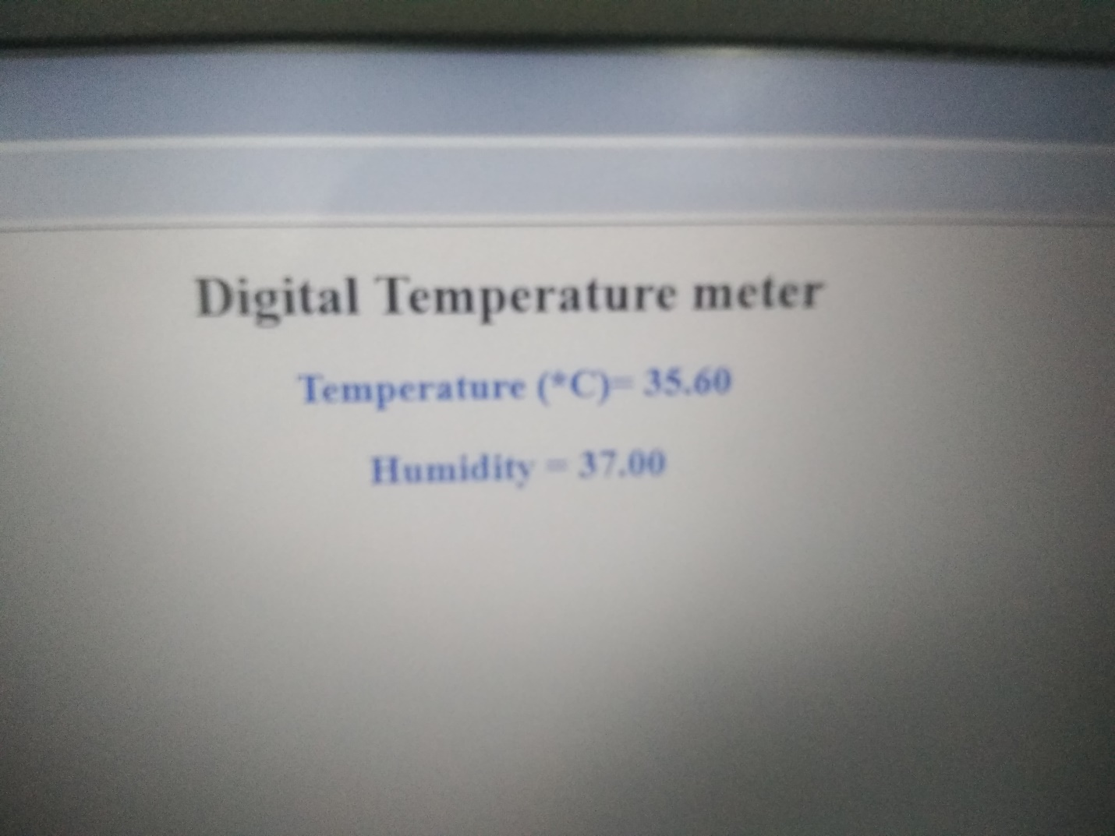

ADVANTAGES:

* FAST RESPONSE
* IT HAS EXCELLENT QUALITY
* ANTI-INTERFERENCE ABILITY
* IT INCLUDES THE RESISTIVE ELEMENT

CONCLUSION:

* In this project we design and implemented an efficient temperature and humidity monitoring and controlling system with an ardunio board
* Output was verified according to the room temperature on LCD, web page and thing speak